Stony Point High School Baseball Booster Club

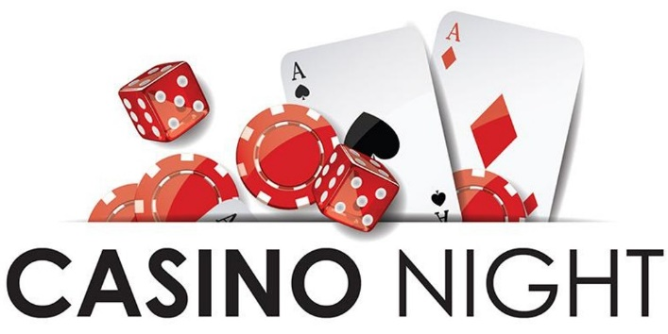
Saturday January 18, 2020
7:00 pm – 11:00 pm
Old Settlers Association Main Hall
3300 E Palm Valley Blvd, Round Rock, TX 78665

Your business has been identified as having a strong commitment to our local youth programs. We would like to invite you to be a part of our exciting event. This year your support is a key element in our overall success. There are multiple ways you can support Stony Point HS Baseball Booster Club in this endeavor, including our casino night fundraiser.

This is our 2nd annual event and will include dinner, drinks, music, raffle, silent auction and of course casino games. Casino Night is hosted by the Stony Point Baseball Booster Club and is the club’s largest fundraiser.

● Sponsorship of a table at the event ● Donation of a basket to be raffled off
● Donation of items for silent auction ● Contribution of volunteers

We look forward to your tax-deductible sponsorship this year! Thank you for your support of the Stony Point Baseball Program.

Sincerely,

Kristin Fairbanks
Stony Point High School Booster Club
512-497-5147

YES! I would like to donate the following item(s) to the Stony Point Baseball Booster Silent Auction

Business Name: _____________________________________________________

Contact name and number: ____________________________________________

Item(s) Donated: ____________________________________________________

Value: _____________________________________________________________

Please contact Kristin Fairbanks to have items picked up or feel free to send items to:
Stony Point Baseball Booster Club c/o Kristin Fairbanks
1801 Tiger Trail Round Rock, Texas 78664

